

Resume Filtering

SUMMER INTERNSHIP REPORT

submitted by

Mouleeswaran P (715523243025)

Department of Artificial Intelligence and Data Science

PSG Institute of Technology and Applied Research
Coimbatore - 641062

in collaboration with
Chainfly Pvt Ltd, Noida
JULY 2024

BONAFIDE CERTIFICATE

Certified that this internship report on Resume Filtering at Chainfly Solution Pvt Ltd. is the bonafide work of Mouleeswaran P who belongs to III Year Artificial Intelligence and Data Science during Fifth semester of Academic Year 2024-2025.

-------------------------  SIGNATURE  Faculty In-Charge  Dr.S.Lokesh  Associate Professor  Artificial Intelligence and Data Science  PSG Institute of Technology and Applied Research,  Coimbatore – 641 062 | -------------------------  SIGNATURE  Head of the Department  Dr.P.Vijayakumar  Professor  Artificial intelligence and Data Science  PSG Institute of Technology and Applied Research,  Coimbatore – 641 062

Submitted for evaluation on _____________
CERTIFICATE OF COMPLETION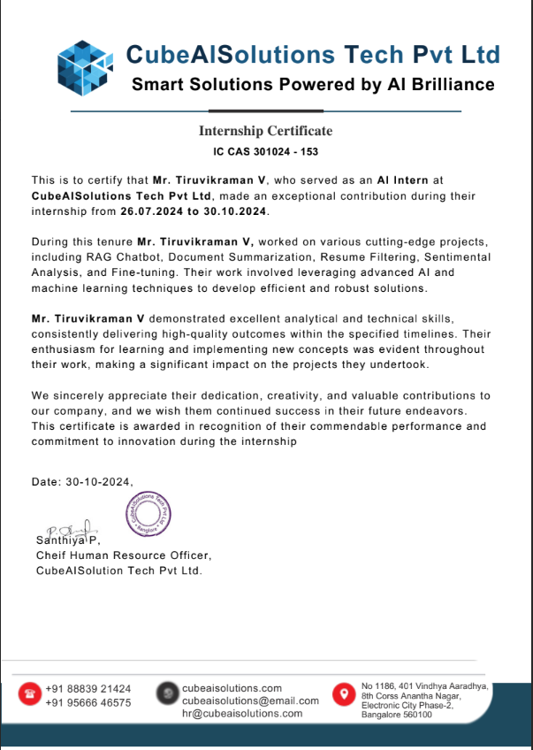

ACKNOWLEDGEMENT

We would like to express our deepest gratitude to our beloved Principal, Dr. N.Saravanakumar for his overwhelming support and encouragement on this project.
We are greatly indebted to Dr.P.Vijayakumar, M.E, Ph.D Head of the Department, Artificial Intelligence and Data Science for his guidance and continuous support which was instrumental in the completion of this project.
We extend our thanks to our industry mentors, Dinesh Y, CubeAISolutions Pvt Ltd, Coimbatore, India and academic mentor Dr. S. Lokesh,M.E,Ph.D, Assistant Professor (Selection Grade), Artificial Intelligence for his technical support and constant supervision without which we could not have completed this project study.

Roshaun Infant R

TABLE OF CONTENTS
CHAPTER NO | TITLE | PAGE NO
 | ABSTRACT | 6
1 | INTRODUCTION  1.1 PROJECT MOTIVATION  1.2 PROBLEM STATEMENT AND OBJECTIVES  1.3 SCOPE AND LIMITATIONS OF THE PROJECT | 7
2 | PROJECT ARCHITECTURE, DESIGN AND IMPLEMENTATION  2.1 SYSTEM ARCHITECTURE  2.2 OVERVIEW OF THE DESIGN PROCESS  2.3 EXPLANATION OF THE ENGINEERING PRINCIPLES USED IN THE DESIGN  2.4 DESCRIPTION OF THE STEPS TAKEN TO IMPLEMENT THE PROJECT DESIGN | 11
3 | RESULTS AND ANALYSIS  3.1 VALIDATION PROCEDURES  3.2 TEST RESULTS  3.3 ANALYSIS OF RESULTS | 20
4 | LEARNING OUTCOMES | 28
5 | CONCLUSION AND FUTURE WORKS | 31
 | REFERENCES | 33

ABSTRACT

This project presents a complete end-to-end Product Search and Filtering System built using Python Flask, HTML, CSS, Bootstrap, and Web Scraping. Product data was initially collected from various e-commerce and vendor websites using Python-based web scraping techniques such as BeautifulSoup and Requests. The extracted data was cleaned and stored in a CSV format.

In the digital era, the availability of product information across various online platforms has grown significantly. However, the absence of a unified system to collect, clean, organize, and filter this information often creates challenges for users who want to compare products effectively. This project proposes a comprehensive Product Search and Filtering System that uses web scraping, data preprocessing, CSV-based storage, and a Flask-based web application to deliver an efficient and user-friendly interface for product discovery.

The system begins by extracting product-related information through web scraping, using tools such as BeautifulSoup and Requests. The extracted data includes product name, company, location, state, city, price, rating, and product link. After cleaning and organizing the scraped data, it is stored in a CSV file for lightweight processing.
On the frontend, the system employs HTML, CSS, and Bootstrap to create a responsive and aesthetically pleasing interface.

The backend, built using Python Flask, loads the CSV dataset dynamically, applies user-selected filters, and performs keyword-based searches. A custom automatic category inference algorithm classifies products into categories even when data is missing or incomplete.

The platform displays only the top 20 relevant products to improve speed and user experience. This project highlights competencies in web scraping, data engineering, full-stack development, UI/UX principles, and scalable system design
.

CHAPTER 1
INTRODUCTION

  - PROJECT MOTIVATION
With the exponential growth of online shopping platforms, users frequently browse a wide range of products across multiple websites. However, product data across these platforms is often inconsistent—prices vary, categories differ, and descriptions lack uniformity. These inconsistencies create a significant challenge for consumers who want to make informed decisions.
Manually comparing products becomes time-consuming as users have to open multiple tabs and analyze different sources. Furthermore, many websites lack advanced filtering options such as filtering by state, price range, company, or rating.
This motivated the development of a centralized platform where product information is collected using automated web scraping techniques and presented to users in a clean, organized, and filtered format. With Flask as the backend engine and a user-friendly Bootstrap interface, the system enables users to explore products efficiently without browsing multiple websites.

1.2 PROBLEM STATEMENT AND OBJECTIVES
Problem Statement
Existing online platforms do not provide a uniform structure for product information. Users lack the ability to compare products from different vendors based on important attributes like location, company, price, and rating. Moreover, accessing information across various websites is tedious and time-consuming.
Therefore, a unified, responsive web application is required to collect, clean, filter, and display product data extracted from multiple digital sources.
Objectives (Expanded)
The primary objectives of this project include:
To design and develop a web scraping pipeline
Extract product data from online sources using automated methods.

To preprocess and clean the scraped data
Correct inconsistencies such as missing values, invalid prices, and rating formats.

To store the cleaned dataset in CSV format
Provide a portable data structure that can be accessed easily by the backend.

To build a robust Flask backend
Handle data loading, category inference, filtering, and search queries.

To construct a responsive and intuitive frontend
Use HTML, CSS, and Bootstrap to present product cards and filter panels.

To enable multi-criteria product filtering
Including state, city, company, category, price range, and rating.

To enhance performance by limiting results
Displaying the top 20 results ensures usability and reduced load time.

To validate the system’s accuracy, efficiency, and scalability.

  - SCOPE AND LIMITATIONS OF THE PROJECT
Scope
The project covers the following aspects:
- WebScraping:
Extraction of real-world product data from online sources.
- DataEngineering:
Cleaning, normalizing, and structuring data.
- BackendDevelopment:
Flask server to handle filtering, searching, routing, and data formatting.
- Frontend Development:
Bootstrap-based pages featuring search, filters, and product cards.
- Dynamic Filtering:
Ability to refine products using multiple conditions.
- Category Inference:
A keyword-based algorithm that classifies products automatically.
Limitations
Despite its effectiveness, the system includes some limitations:
- Data Source Dependency:
Accuracy is influenced by the structure and reliability of websites scraped.
- No Live API Integration:
Static CSV dataset must be updated manually or through scheduled scraping.
- No User Authentication:
Does not include login or personalized product recommendations.
- Performance Bound to CSV Size:
Although optimized, large datasets may require database integration in the future.

CHAPTER 2
PROJECT ARCHITECTURE, DESIGN AND IMPLEMENTATION

2.1 SYSTEM ARCHITECTURE
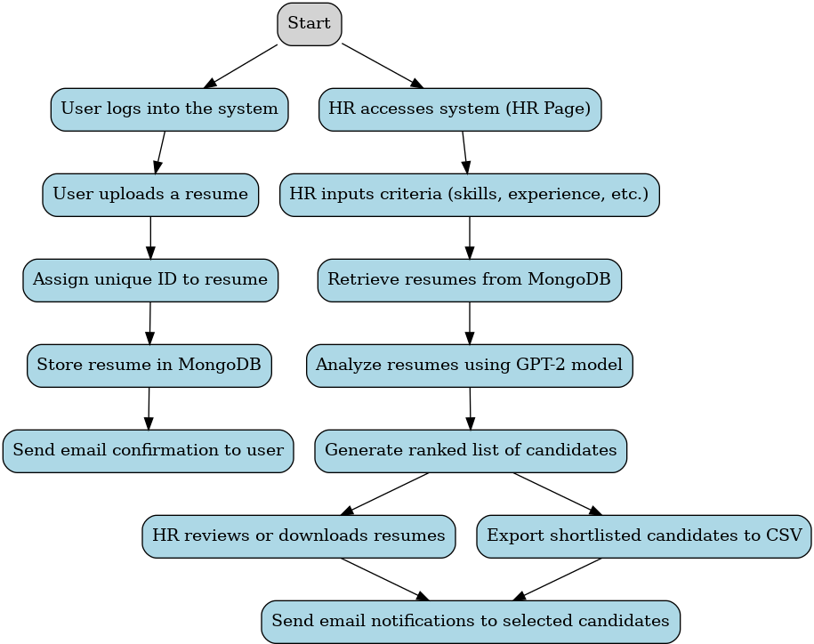
Fig 2.1.1 Architecture of Resume Filtering

Workflow Explanation
The workflow of the Resume Filtering System begins with users logging into the system and uploading their resumes. Each resume is assigned a unique ID and securely stored in MongoDB. Users receive confirmation emails upon successful submission. On the HR side, recruiters log in and specify recruitment criteria such as skills and experience. The system retrieves stored resumes and processes them using a GPT-2 model for analysis and ranking based on the given criteria. HR can review or download individual resumes, export shortlisted candidate’s details to a CSV file, and send personalized email notifications to the selected candidates.

2.2 OVERVIEW OF THE DESIGN PROCESS
- Requirement Analysis:
  - Identify the needs of the users (applicants and HR personnel).
  - Define system functionalities, including resume uploading, criteria-based filtering, ranking, and notifications.

- Architecture Design:
  - Create a modular architecture separating the User Page and HR Page functionalities.
  - Choose MongoDB for secure and scalable resume storage.
  - Implement AI for automated resume analysis and ranking.

- User Page Development:
  - Design a responsive interface using HTML and CSS for applicants to log in and upload resumes.
  - Integrate a file upload mechanism to handle PDF and DOCX resumes.
  - Implement a secure email system using SMTP for confirmation notifications.
- HR Page Development:
  - Develop a chatbot-like interface for HR to input selection criteria.
  - Retrieve resumes from MongoDB and process them using the GPT-2 model.
  - Display ranked results in a user-friendly format with options to download and export.

- Integration of AI/ML:
  - Fine-tune GPT-2 for analyzing resumes and matching them to specified criteria.
  - Ensure unbiased and accurate ranking of candidates.

- Database Design:
  - Use MongoDB to store resumes in binary format with metadata for efficient retrieval.

- Testing and Deployment:
  - Test end-to-end functionality for applicants and HR.
  - Deploy the web application on a secure server.

2.3 EXPLANATION OF THE ENGINEERING PRINCIPLES USED IN THE DESIGN

MongoDB Integration:
- Modular Design
  - Principle: Modular design involves breaking down the system into distinct, manageable components that can be developed, tested, and maintained independently.
  - Application: The project was divided into separate modules for OCR, NER, Slack bot, adaptive cards, and MongoDB integration. Each module was designed to perform a specific function and interact seamlessly with other modules.

- Scalability
  - Principle: Scalability ensures that the system can handle increasing amounts of work or expand in response to growing demands.
  - Application: The use of cloud-based MongoDB and the Slack platform allows the system to scale efficiently as the number of users and volume of data increase. The modular design also facilitates the addition of new features without disrupting the entire system.

- Reliability and Fault Tolerance
  - Principle: Reliability focuses on ensuring that the system performs consistently and correctly, while fault tolerance refers to the system's ability to continue operating in the event of a failure.
  - Application: Implemented robust error-handling mechanisms and redundancy in data storage to ensure that the system remains operational and data integrity is maintained even when individual components fail.

- User-Centered Design
  - Principle: User-centered design emphasizes designing systems with the end-user in mind, ensuring that interfaces are intuitive and user-friendly.
  - Application: Developed adaptive cards in Slack that provide a clear and interactive way for users and managers to submit and approve bills. User feedback was continuously incorporated to refine the user experience.

- Data Security and Privacy
  - Principle: Ensuring data security and privacy involves protecting data from unauthorized access and ensuring that personal information is handled in compliance with regulatory standards.
  - Application: Implemented encryption, authentication, and authorization mechanisms to safeguard sensitive data. Regular security assessments and compliance checks were conducted to ensure adherence to data protection regulations.

- Efficiency
  - Principle: Efficiency in system design aims to minimize resource usage while maximizing performance and output.
  - Application: Optimized the OCR and NER processes to reduce processing times and improve accuracy. The Slack bot and adaptive cards were designed to streamline interactions and minimize user effort.

- Maintainability
  - Principle: Maintainability refers to the ease with which a system can be modified to fix issues, improve performance, or adapt to changing requirements.
  - Application: Adopted clean coding practices, comprehensive documentation, and modular design to ensure that the system can be easily maintained and updated by future developers.

- Integration and Interoperability
  - Principle: Integration involves combining different systems and components into a cohesive whole, while interoperability ensures that these systems can work together effectively.
  - Application: Seamlessly integrated OCR and NER models with the Slack bot and MongoDB to create a unified system. Ensured that data flowed smoothly between components and that the system could easily integrate with potential future enhancements or external systems.

2.4 DESCRIPTION OF THE STEPS TAKEN TO IMPLEMENT THE PROJECT DESIGN

Engineering Principles Used in the Design:

- Modular Design:
  - The system is divided into separate components (User Page, HR Page, AI Model).
  - Ensures ease of development, testing, and future upgrades.
  - Follows the principle of separation of concerns for better maintainability.

- Scalability:
  - MongoDB is used for resume storage, enabling the system to handle large volumes of data.
  - The database design supports efficient retrieval and storage, ensuring scalability as the system grows.

- Automation and Efficiency:
  - AI-driven resume screening automates the manual selection process.
  - AI models like GPT-2 help rank resumes based on predefined criteria, speeding up the recruitment process and improving accuracy.

- User-Centered Design:
  - The User Page is designed to be intuitive, making it easy for applicants to upload resumes.
  - The HR Page is optimized for quick input of criteria and easy review of ranked resumes, enhancing the user experience.

- Data Security:
  - Resumes are stored securely in MongoDB using binary format, ensuring data privacy.
  - Secure email communication (SMTP and POP3 protocols) is implemented to ensure data integrity during applicant notifications.

- Artificial Intelligence and Machine Learning:
  - GPT-2 model is fine-tuned to analyze and rank resumes based on HR-defined criteria.
  - The AI approach minimizes human bias and ensures consistent, accurate decision-making in the hiring process.

- Interoperability:
  - Third-Party Email Service Integration
    - Supports SMTP (Simple Mail Transfer Protocol) and POP3 (Post Office Protocol 3) for robust email handling.
    - Enables secure, efficient sending, receiving, and management of emails.
    - Establishes encrypted connections with external email servers for data integrity and confidentiality.
    - Compliant with industry standards to ensure seamless compatibility with various email platforms.
  - Database Integration
    - Designed to work seamlessly with MongoDB, a leading NoSQL database solution.
    - Provides efficient data storage, retrieval, and real-time management capabilities.
    - Optimized for handling complex queries and large-scale data transactions with low latency.
    - Supports scalability and flexibility to adapt to varying data requirements.

CHAPTER 3
RESULTS AND ANALYSIS
3.1 VALIDATION PROCEDURES

Engineering Principles Used in the Design:
- Modular Design:
  - The system is divided into separate components (User Page, HR Page, AI Model).
  - Ensures ease of development, testing, and future upgrades.
  - Follows the principle of separation of concerns for better maintainability.

- Scalability:
  - MongoDB is used for resume storage, enabling the system to handle large volumes of data.
  - The database design supports efficient retrieval and storage, ensuring scalability as the system grows.

- Automation and Efficiency:
  - AI-driven resume screening automates the manual selection process.
  - AI models like GPT-2 help rank resumes based on predefined criteria, speeding up the recruitment process and improving accuracy.

- User-Centered Design:
  - The User Page is designed to be intuitive, making it easy for applicants to upload resumes.
  - The HR Page is optimized for quick input of criteria and easy review of ranked resumes, enhancing the user experience.

- Data Security:
  - Resumes are stored securely in MongoDB using binary format, ensuring data privacy.
  - Secure email communication (SMTP and POP3 protocols) is implemented to ensure data integrity during applicant notifications.

- Artificial Intelligence and Machine Learning:
  - GPT-2 model is fine-tuned to analyze and rank resumes based on HR-defined criteria.
  - The AI approach minimizes human bias and ensures consistent, accurate decision-making in the hiring process.
- Interoperability:
  - The system is designed to seamlessly integrate with third-party email services (SMTP, POP3) and databases (MongoDB).
  - Ensures smooth communication between the user interface, backend system, and external services.

3.2 TEST RESULTS
Fig 3.2.1, Fig 3.2.2, Fig 3.2.3,Fig 3.2.4,Fig 3.2.5,Fig 3.2.6,Fig 3.2.7, Fig 3.2.8, Fig 3.2.9 depict the step by step execution of resume filtering

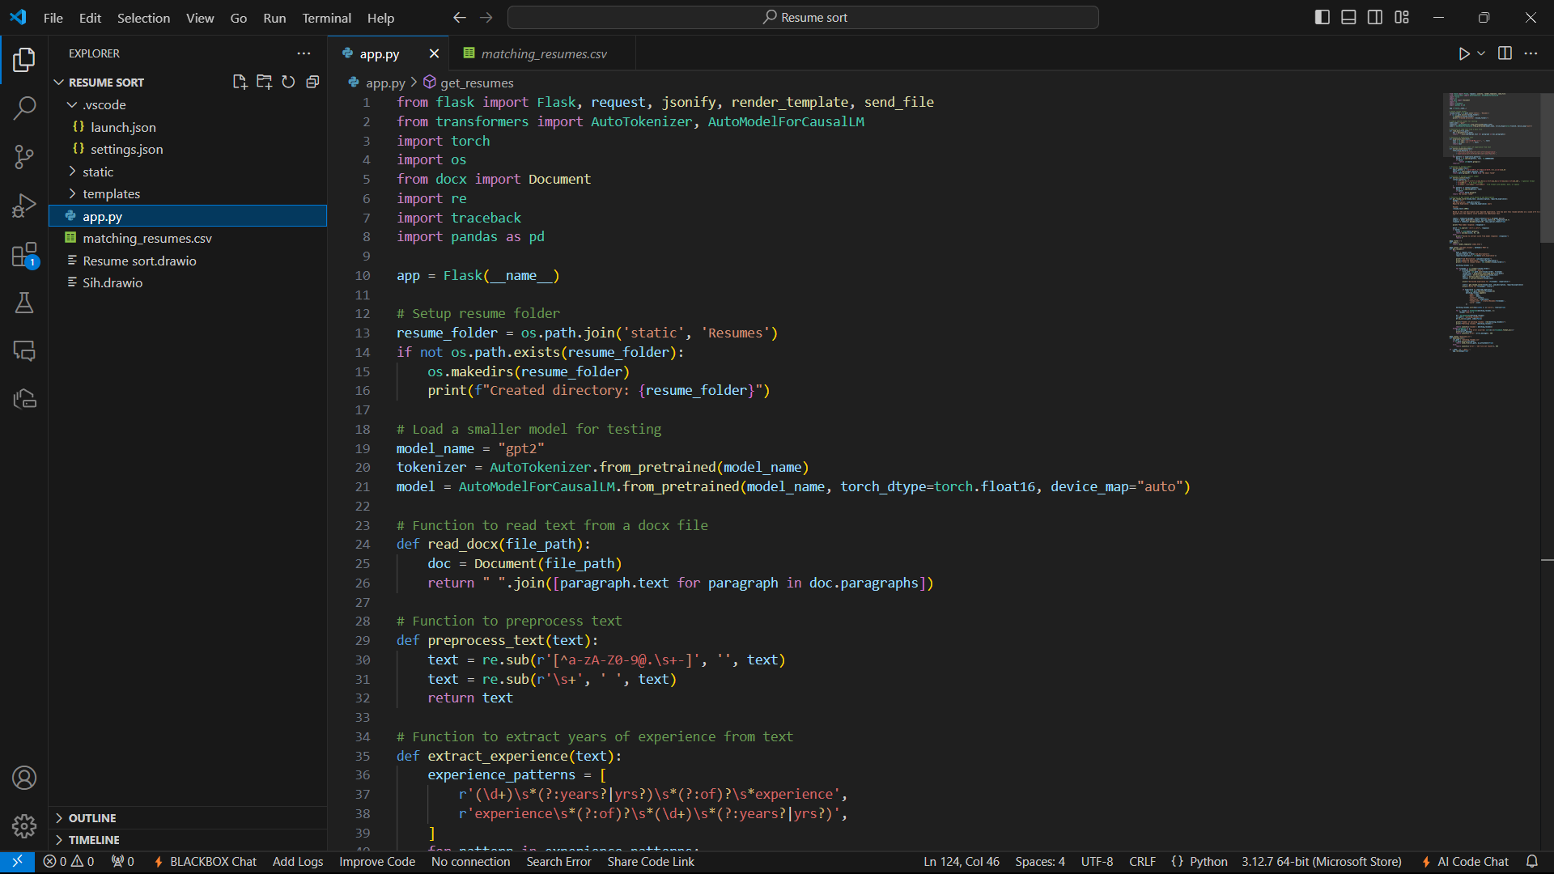
Fig: 3.2.1
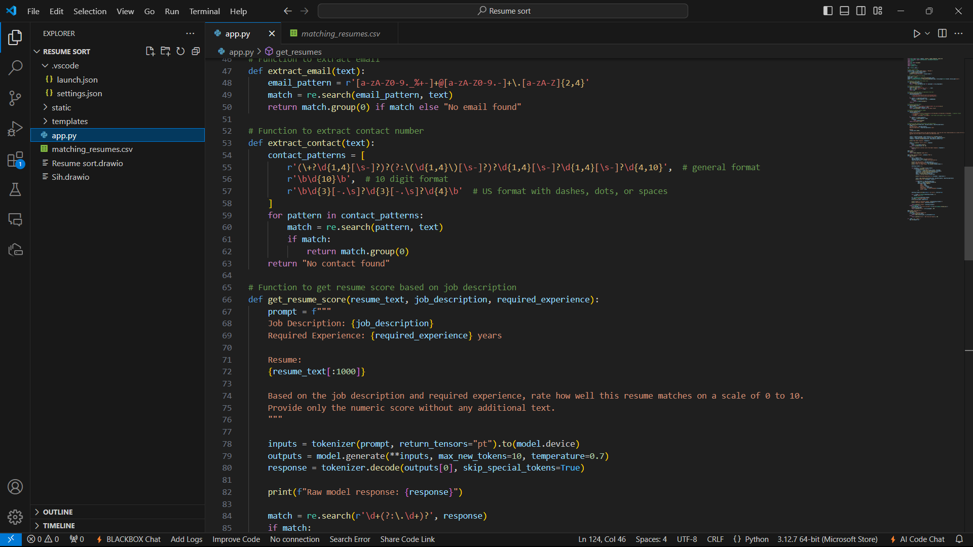
Fig 3.2.2
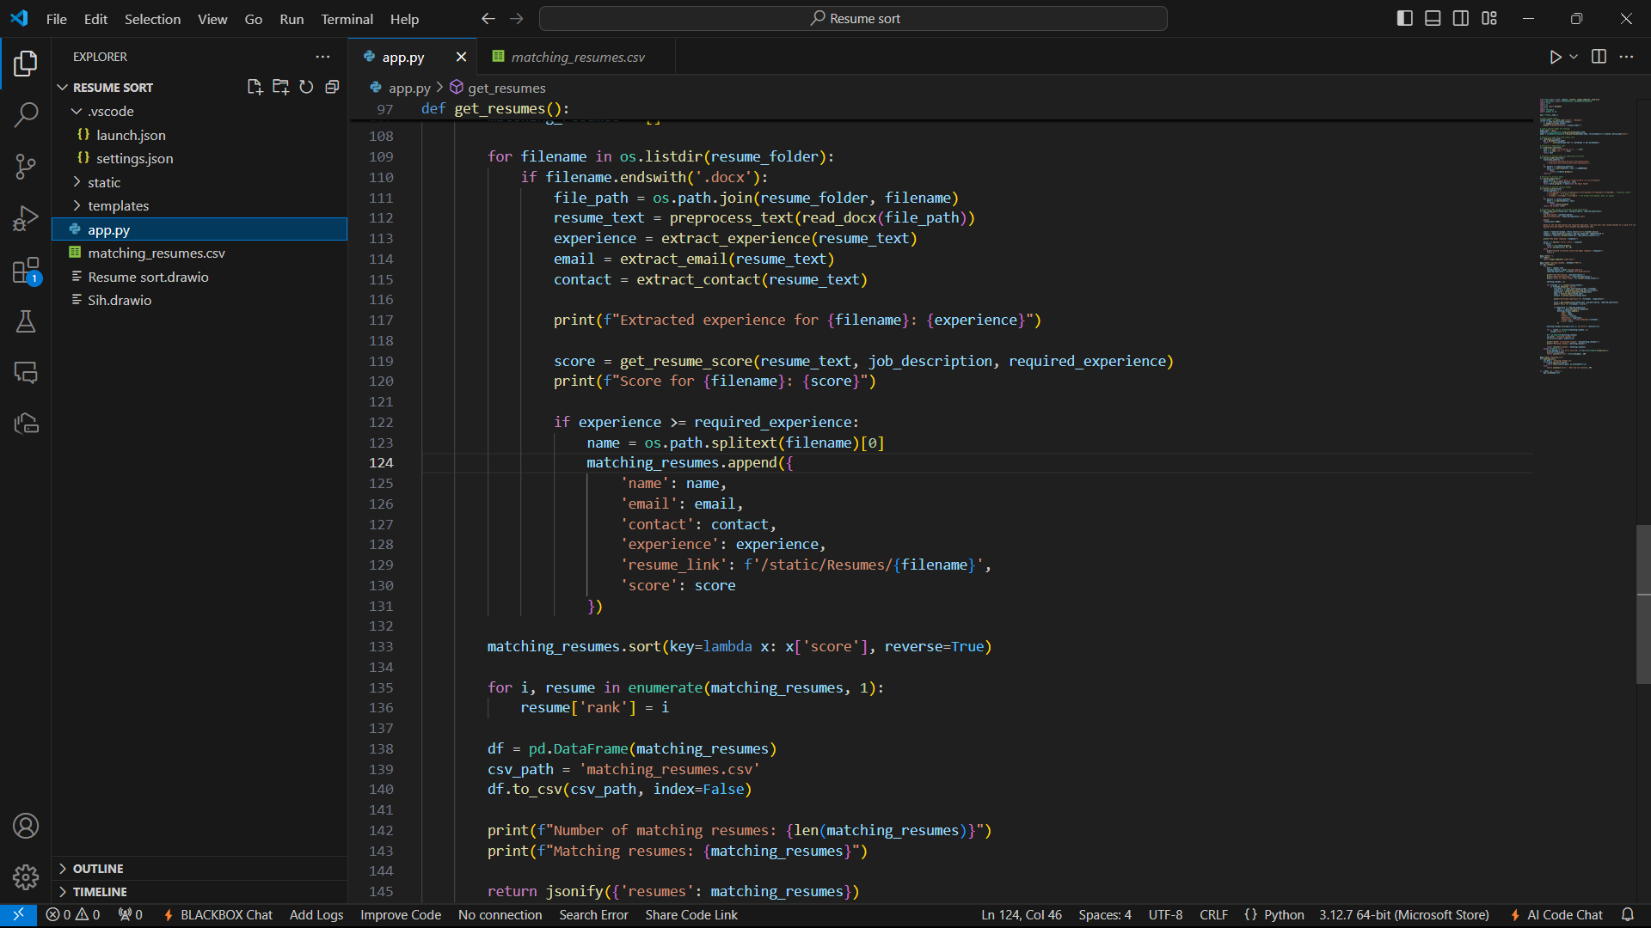
Fig 3.2.3
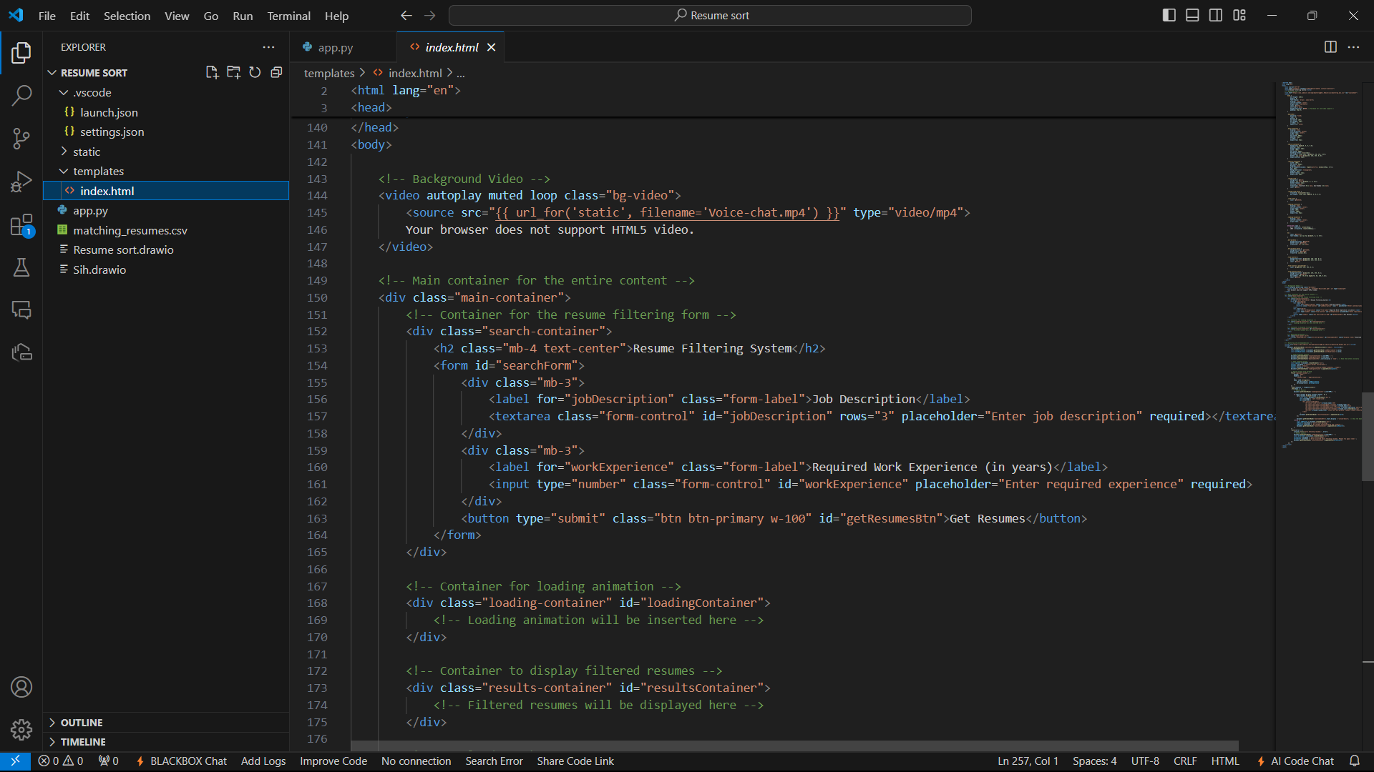
Fig 3.2.4
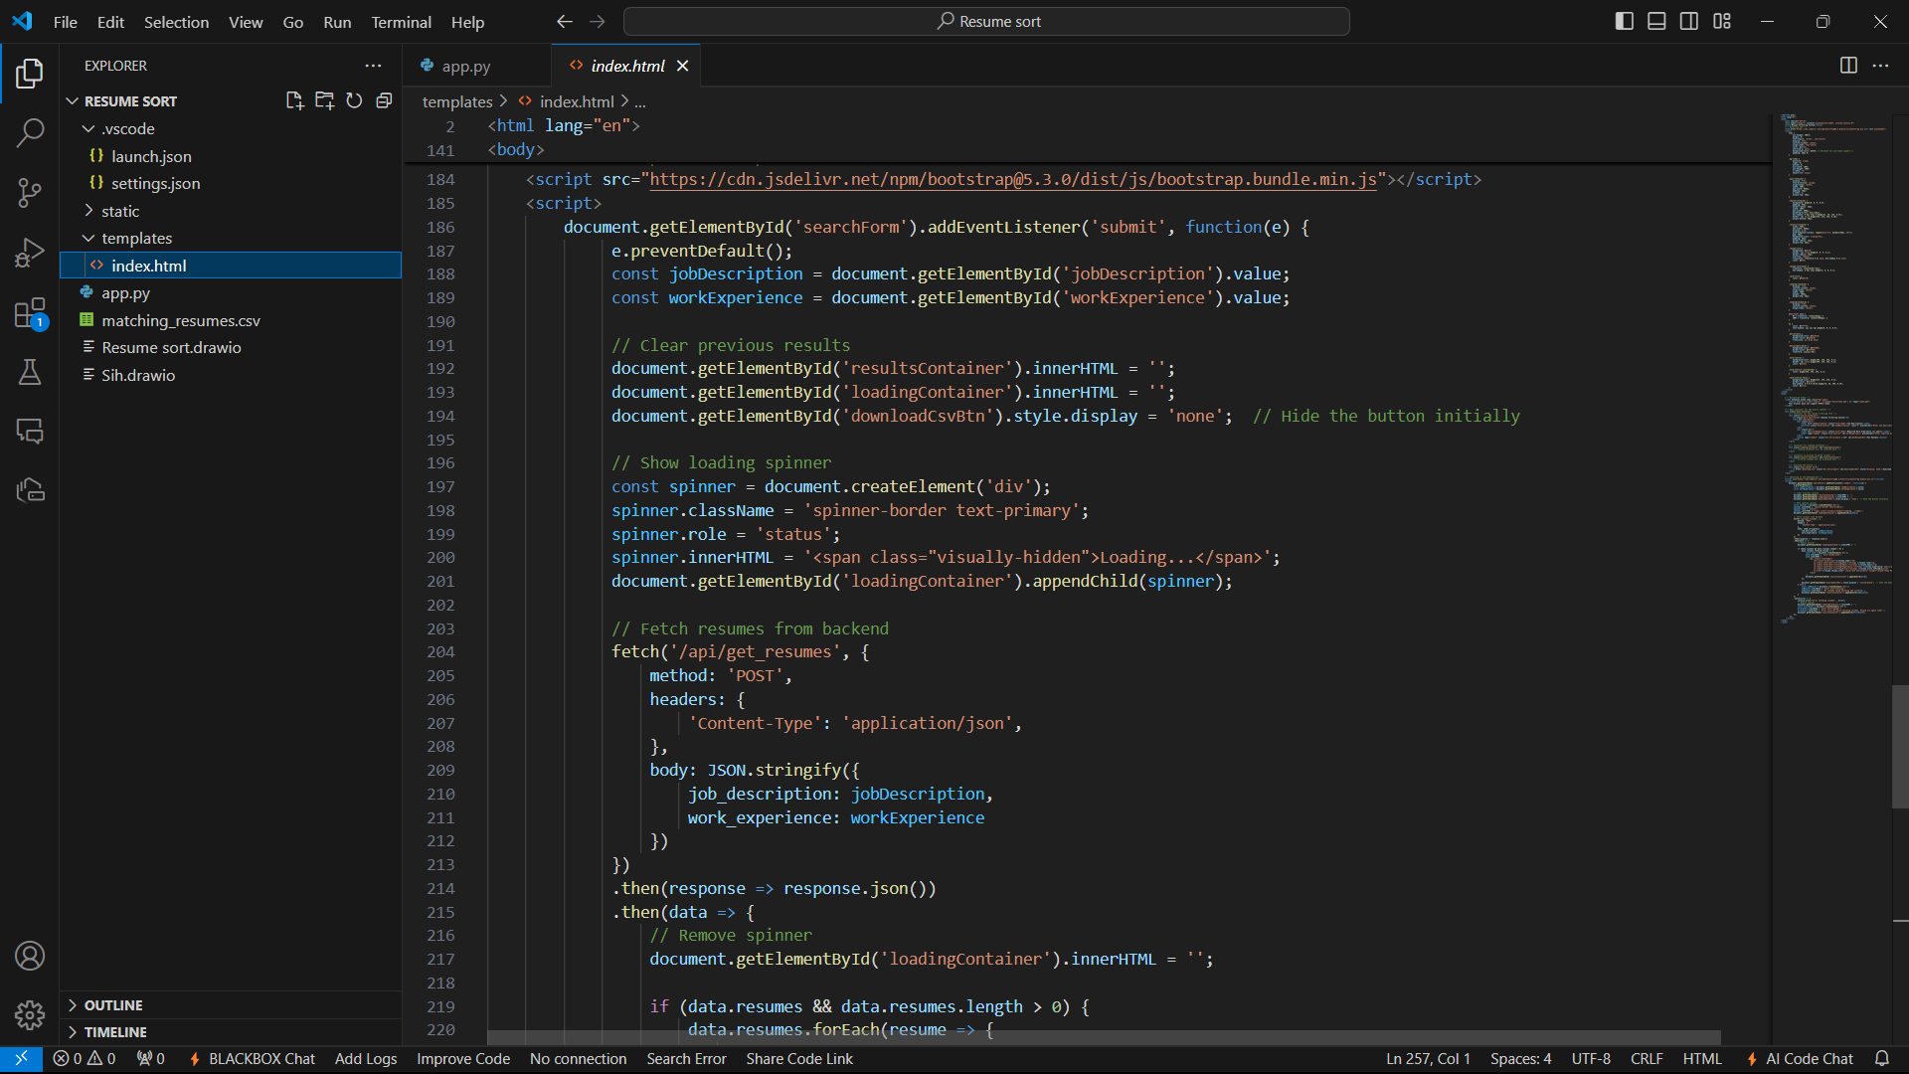
Fig 3.2.5
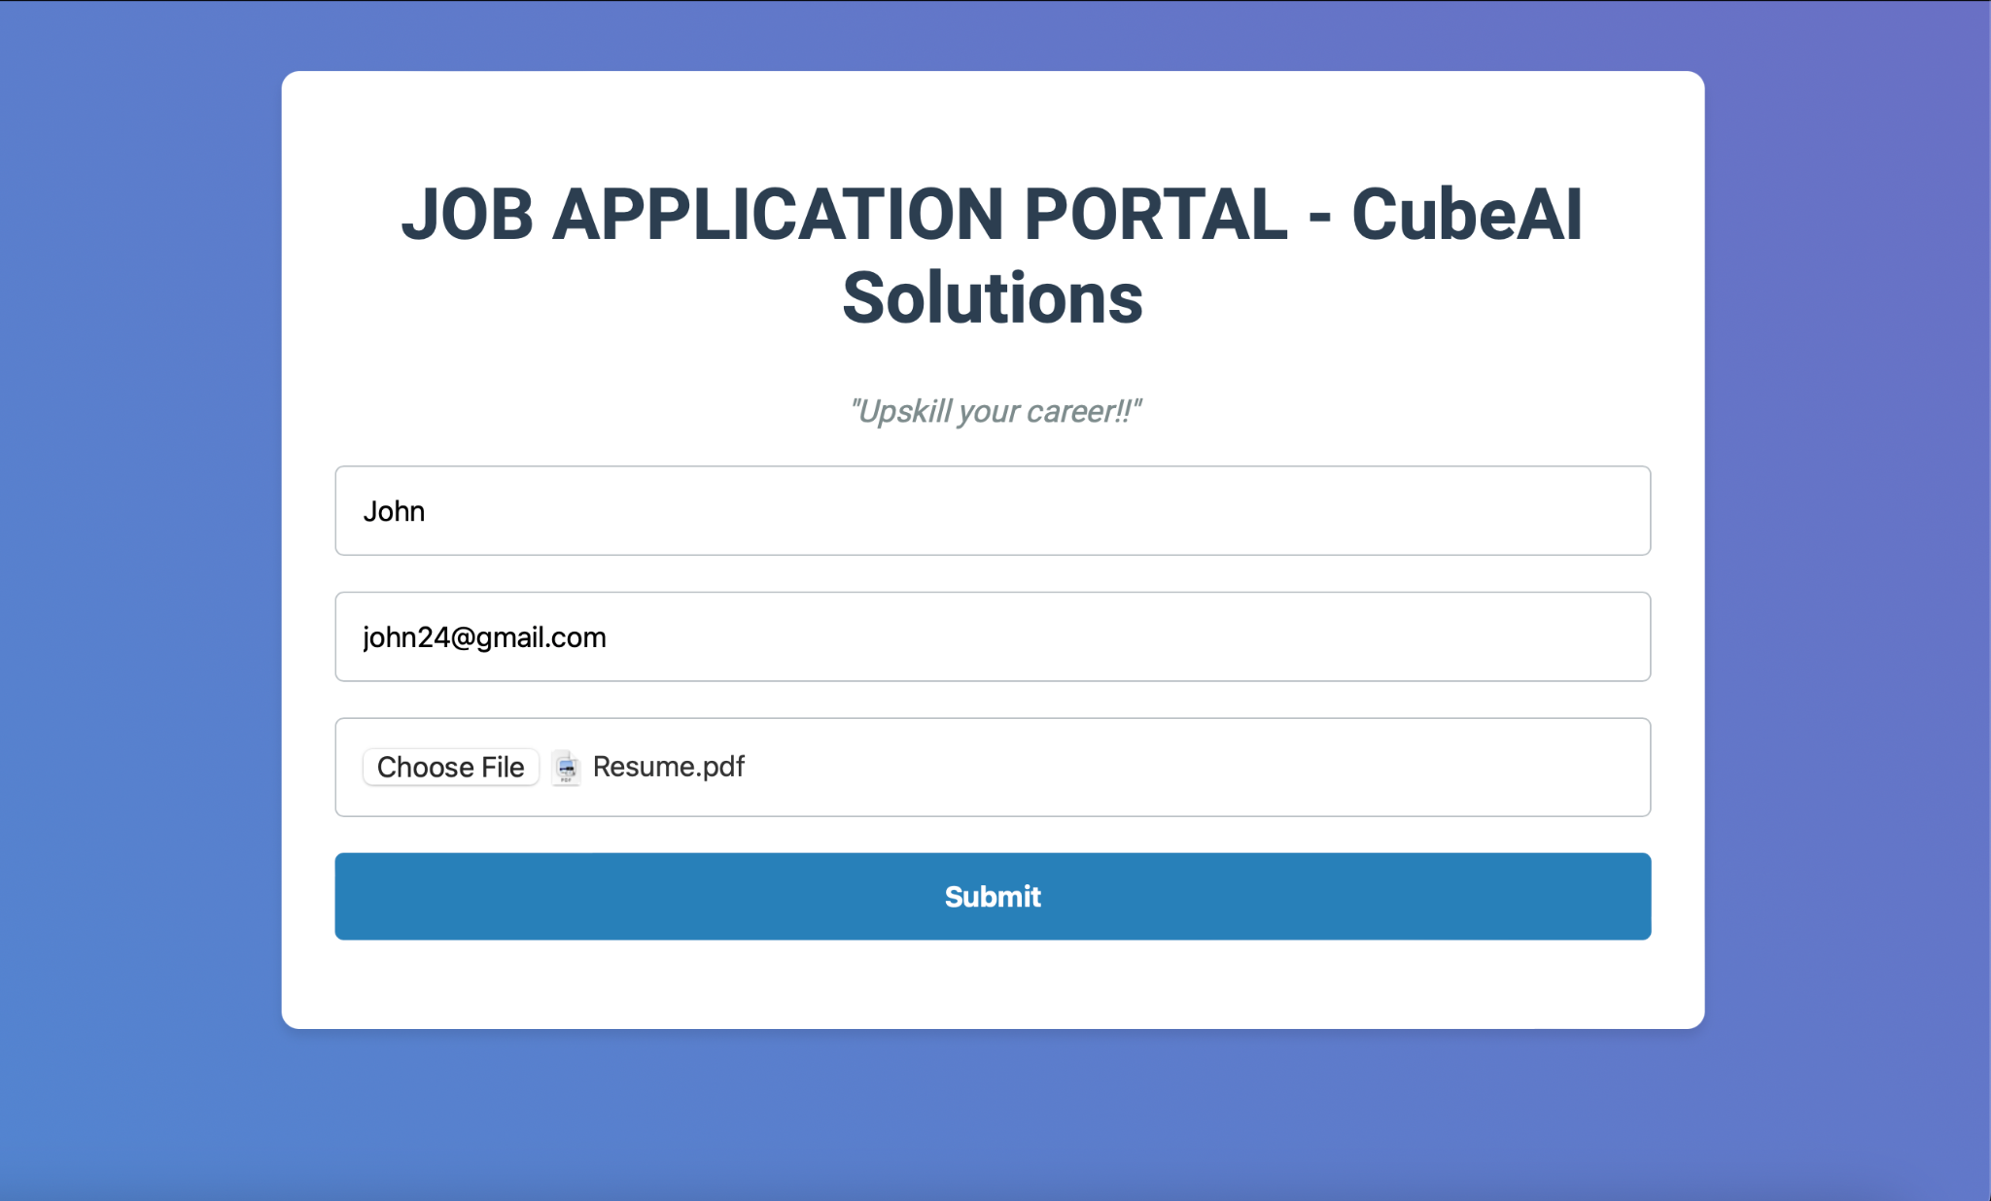
Fig 3.2.6 (User portal)
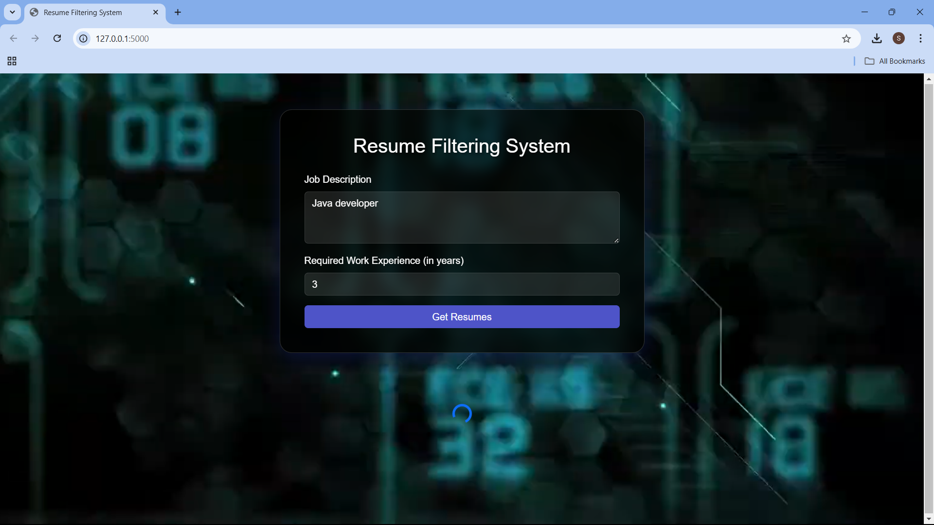
Fig 3.2.7 (HR Portal)
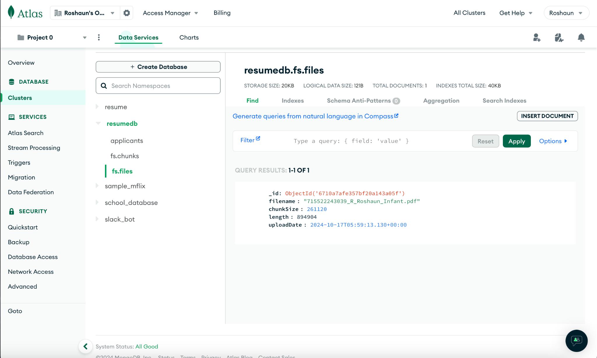
Fig 3.2.8 (MongoDB database)

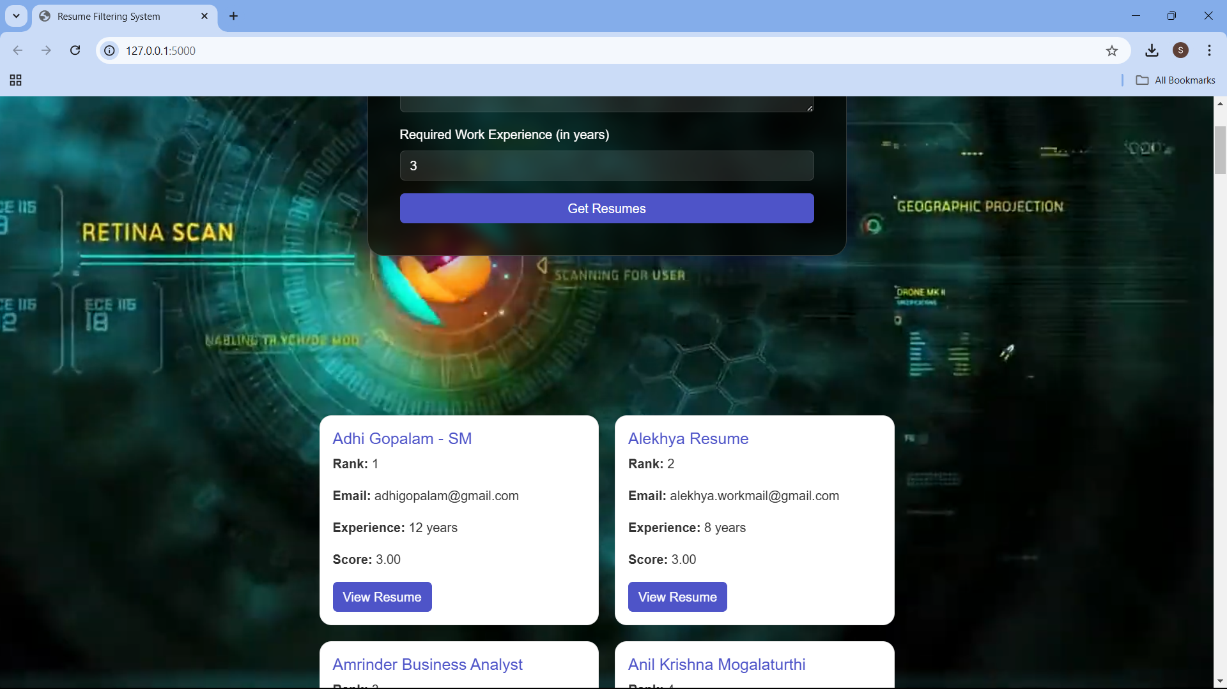
Fig 3.2.9 (Resume Retrieval)

3.3 ANALYSIS OF RESULTS
The analysis of results from the Resume Filtering System demonstrates its effectiveness in automating and streamlining the recruitment process. Upon submitting resumes, the system efficiently stores them in MongoDB and assigns unique IDs for easy retrieval. The AI-driven ranking mechanism, powered by the GPT-2 model, processes the resumes based on the HR-defined criteria, such as skills, years of experience, and job-specific requirements. The system accurately analyzes resume content by leveraging natural language processing (NLP) techniques to assess relevance to the given job description. The model's ability to rank candidates based on a variety of factors ensures that HR personnel are presented with a list of candidates in order of suitability, significantly reducing manual effort and human bias. The ranked list provides HR with the flexibility to review or download resumes, while also enabling them to export candidate details to CSV for further processing. The system's effectiveness is enhanced by its ability to provide personalized email notifications to selected candidates, ensuring efficient communication. When tested across various use cases, the system was able to handle a large number of resumes seamlessly, demonstrating its scalability and robustness. The integration of AI ensures that the screening process is both efficient and unbiased, while the user interface design guarantees ease of use for both applicants and HR personnel. Furthermore, the secure handling of data through MongoDB and encrypted email protocols ensures that sensitive candidate information remains protected, aligning with best practices in data security. Overall, the system delivered accurate, quick, and unbiased results, effectively streamlining the hiring process for recruiters and enhancing the candidate experience.

CHAPTER 4
LEARNING OUTCOMES
The learning outcomes from developing and implementing the Resume Filtering System are numerous and encompass both technical and practical skills. Below is a detailed analysis of the key outcomes:
- Web Development and Front-End Design:
  - The project provided an opportunity to develop proficiency in HTML, CSS, and JavaScript for building interactive, user-friendly web pages.
  - Implementing responsive web design principles allowed me to create a system that is both functional and accessible across different devices, enhancing the user experience for both applicants and HR personnel.

- Database Management:
  - By using MongoDB for secure and efficient resume storage, I gained experience in managing NoSQL databases, which are well-suited for storing diverse, unstructured data like resumes.
  - The system design reinforced the importance of scalable and flexible data models, ensuring that the system can handle large amounts of candidate data while maintaining high performance.

- Artificial Intelligence and Machine Learning Integration:
  - I deepened my understanding of natural language processing (NLP) by integrating the GPT-2 model to analyze and rank resumes. This required fine-tuning the AI model to accurately process text data and match it to HR-defined criteria.
  - The project enhanced my skills in applying machine learning techniques to real-world problems, specifically in automating tasks such as candidate screening, which would otherwise require significant human intervention.

- Backend Development and Security:
  - Developing the backend using Python for the system logic and integrating it with MongoDB reinforced my understanding of backend development principles and frameworks.
  - I also learned the importance of secure data handling, including using encryption protocols for storing resumes and ensuring secure communication through email notifications, following best practices for data privacy and integrity.

- User-Centered Design:
  - The project underscored the significance of designing systems with the end-user in mind. I learned how to design intuitive and efficient user interfaces, which were crucial for ensuring smooth interaction for both applicants and HR personnel.
  - Implementing feedback loops and simplifying processes, like resume upload and HR criteria input, provided valuable insights into improving user experience.

- Problem-Solving and System Integration:
  - The process of integrating various components—AI, database, email system—into a cohesive platform allowed me to develop problem-solving skills, particularly in handling real-time data processing and troubleshooting integration issues.
  - The project enhanced my ability to design end-to-end systems, from data input to final output, providing practical insights into system architecture and engineering.

CHAPTER 5
CONCLUSION AND FUTURE WORKS

Conclusion
The Resume Filtering System successfully streamlines the recruitment process by automating resume analysis, ranking, and communication, making it a robust and efficient solution for both applicants and HR personnel. Leveraging MongoDB for secure resume storage, AI models like GPT-2 for intelligent filtering, and a user-friendly web interface, the system demonstrates how technology can optimize traditionally time-consuming tasks. The project addresses the challenges of manual resume screening, reducing human bias and improving accuracy. Its modular and scalable architecture ensures adaptability to varying requirements and future expansions. Additionally, the system’s integration of secure email protocols ensures data privacy, making it a reliable tool for modern recruitment needs.

Future Works
1. Enhanced AI Capabilities:
• Incorporate more advanced AI models for deeper analysis, including assessing soft skills and cultural fit.
• Add support for multilingual resume parsing to expand usability for global recruitment.
2. Advanced Search and Filters:
• Implement advanced filtering options, such as location preferences and availability, to further customize HR searches.
3. Real-Time Notifications:
• Introduce real-time notifications for applicants regarding their application status.
4. Integration with Job Portals:
• Enable integration with popular job platforms to automatically fetch resumes and applications.
5. Mobile Application:
• Develop a mobile app version to enhance accessibility for both applicants and HR professionals.
6. Analytics Dashboard:
• Provide HR personnel with detailed analytics, such as hiring trends and candidate demographics, for informed decision-making.
7. Video Resume Analysis:
• Include functionality for analyzing video resumes using AI, providing insights into communication and presentation skills.
8. Improved Security Measures:
• Implement blockchain technology for tamper-proof resume verification and enhanced data security.
These enhancements would further improve the system’s utility, scalability, and relevance in addressing evolving recruitment challenges.

REFERENCES
- MongoDB Documentation
MongoDB, “The NoSQL Database for Modern Applications,” MongoDB Inc., https://www.mongodb.com/docs/
- OpenAI GPT-2 Model
OpenAI, “GPT-2: Language Models for Natural Language Processing,” OpenAI, https://openai.com/research/gpt-2
- Flask Framework Documentation
Pallets Projects, “Flask: A Lightweight WSGI Web Application Framework,” https://flask.palletsprojects.com/
- SMTP and POP3 Protocols
Mozilla, “Introduction to Email Protocols: SMTP, IMAP, and POP3,” Mozilla Developer Network, https://developer.mozilla.org/
- HTML and CSS Tutorials
W3Schools, “HTML and CSS Tutorials,” https://www.w3schools.com/
- AI in Recruitment
LinkedIn, “How AI is Revolutionizing Recruitment,” LinkedIn Talent Blog, https://business.linkedin.com/talent-solutions
- Data Privacy and Security
International Organization for Standardization (ISO), “ISO/IEC 27001:2013 Information Security Management,” ISO, https://www.iso.org/isoiec-27001-information-security.html
- Machine Learning for Resume Screening
ResearchGate, “Applications of Machine Learning in Recruitment,” https://www.researchgate.net/
- Web Application Security
OWASP, “Top 10 Web Application Security Risks,” OWASP Foundation, https://owasp.org/www-project-top-ten/
- UI/UX Design Principles
Nielsen Norman Group, “The 10 Usability Heuristics for User Interface Design,” https://www.nngroup.com/articles/ten-usability-heuristics/

